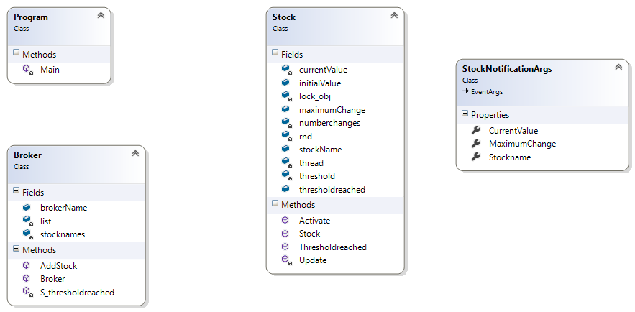

1.\*

1.\*

Calls

Calls

Owns

0.\* 0.\*

1

0.\*

1 Calls 0.\*